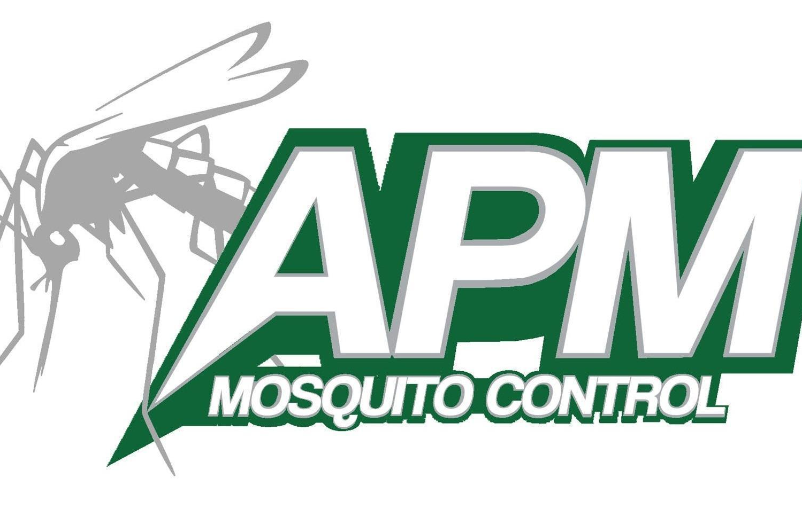
OFFICE USE ONLY
ML YC
OR MB
CEA MAP RES
BOOK MAP ORR
SCN DOC & UPLD
RTE & MAP #

4136 Holiday Drive
Flint MI 48507
(810) 766-9423 Local
(877) 276-4714 Toll Free and Fax
www.advancedmosquito.com

2020 OFF ROAD ACCESS TREATMENT CONSENT FORM
PLEASE READ IN ITS ENTIRETY THEN FILL OUT THIS FORM COMPLETELY

I hereby request, license and authorize an APM Mosquito Control vehicle and employee(s) to access my property, including if necessary, to drive off my driveway and to adulticide and/or larvicide for mosquitoes.

PROPERTY OWNER’S INFORMATION
PLEASE PRINT

__________________________________________________________________________________________
PRINT OWNER’S NAME OWNER’S SIGNATURE

__________________________________________________________________________________________
ADDRESS (& LOT # IF APPLICABLE) CITY STATE ZIP CODE

__________________________________________________________________________________________
NEAREST CROSS STREET TOWNSHIP

______________________________________________________(___________)________________________
DATE TELEPHONE #

__________________________________________________________________________________________
MAILING ADDRESS (IF DIFFERENT)
Qualifying Guidelines: Must be Full Time Residential property (For property used for vacationing/visiting, please call 5 days in advance of occupancy. We will treat your property prior to your arrival. NO NEED TO FILL OUT THIS FORM.)
~ and a minimum of 1 of the following guidelines~
1) House is 150 feet, or more, off the road
2) 1 Acre, or more, of treatable land
3) House is encapsulated by trees, as to where the fog will not penetrate the trees and reach
your house.

All gates, cables, ropes, etc. must be opened and/or removed from the driveway in order to obtain access to the premises without exiting our vehicles. This form does not automatically accept your property for our “Off Road” program. A quick survey from our field technician will be the determining factor. IF your property is approved, a green stake will be placed near your driveway, please keep this free of grass & weeds so it may be used as an indicator to the drivers in the evening.

Any treatment request for more than just the driveway, requires a map of your property, please use a separate sheet of paper. The map must indicate the location of your septic/drain field, well head, or anything that may cause damage to your property or our trucks. The map will be used as a guide where not to drive. The route to be treated will be the discretion of the driver. All residents in our “off road” program will receive an automated call on the day we intend to spray, weather permitting.

IMPORTANT: If this form is not returned, your name and address may be removed from our “Off Road” list. Therefore, if you wish to be/remain an “Off Road”, please return this form to the address at the top of the page, OR email it to apmmosquitosouth@gmail.com OR fax it to the phone number at the top of the page, within 30 days of postmark, so our records may be updated for the current mosquito control season. Your cooperation is greatly appreciated.

