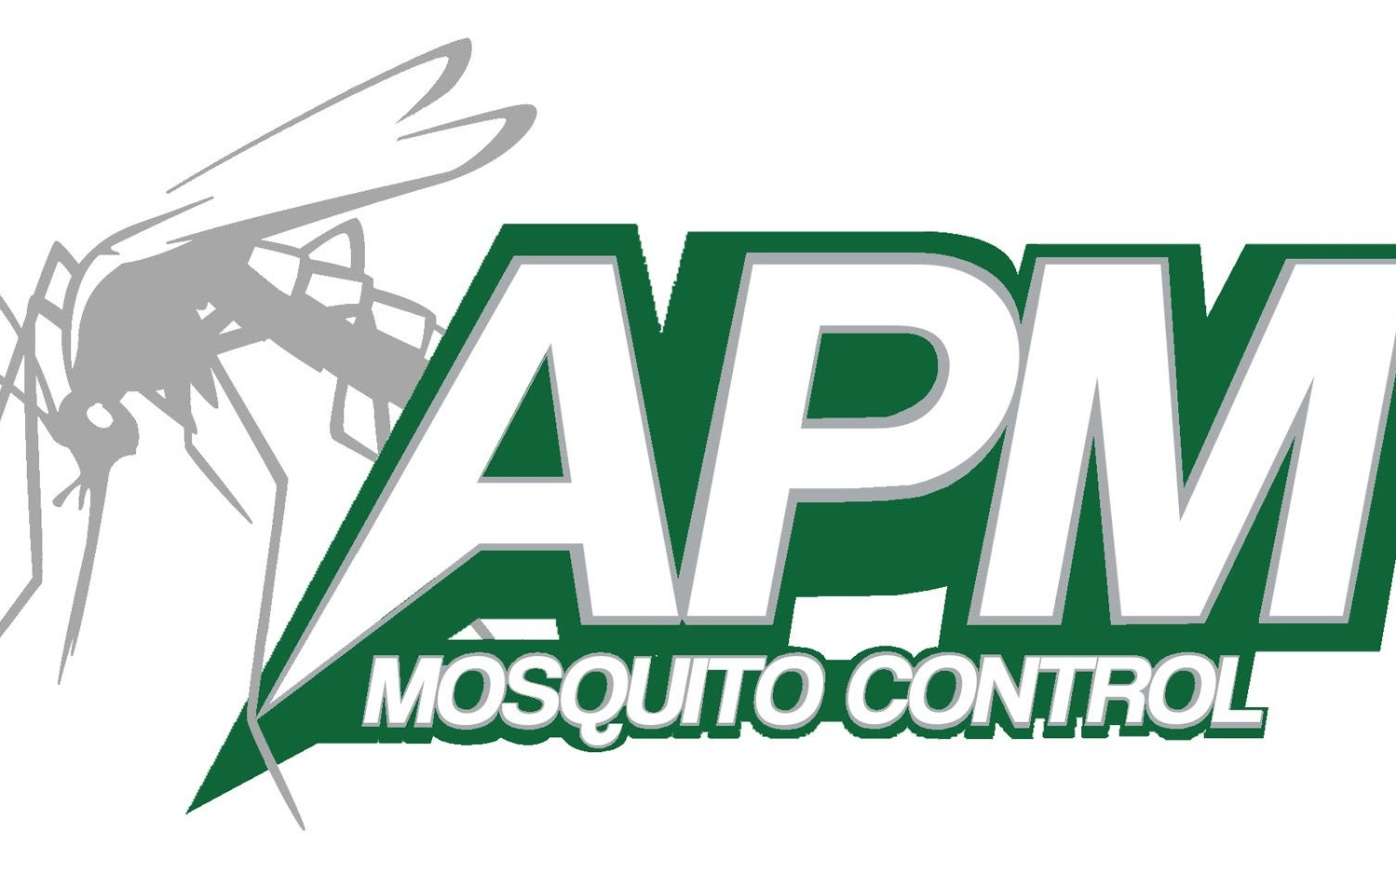
4136 Holiday Drive
Flint, MI 48507
(877) 276-4714 Toll Free & Fax
810-766-9423
www.advancedmosquito.com

OPPORTUNITY TO OPT OUT OF TREATMENT

This is a letter of objection. The following property owner or resident prefers that their property NOT be treated for mosquito control.

Name ________________________________________________________________
Property Address________________________________________________________
City_________________________________________ Zip_______________________
Nearest Cross Street to Residence__________________________________________
Township ______________________________________________________________
Telephone (Main) __________________________ (Secondary)___________________
(Mailing address if different)_______________________________________________
________________________________________________

______________________________________________________________________
Signature Date

Please visit our website at advancedmosquito.com for FAQ, pesticide information, and general mosquito knowledge.

Please send this form to the address at the top of the page, or it may be emailed to apmmosquitosouth@gmail.com, or faxed to the number at the top of the page.

IMPORTANT: Please understand that opting out of treatment does not relieve you from paying the voted millage.

